Guide to NIXSW fitting

**Before you start…**

Make sure you understand the theory of NIXSW before analysing, as otherwise why you are doing this/the data you get out won’t make much sense. These are a couple of good starting guides on the theory of NIXSW and how it is used:

D P Woodruff 2005 *Rep. Prog. Phys.* **68** 743

Robert G Jones *et al* 2002 *J. Phys.: Condens. Matter* **14** 4059

Contents

Requirements: 2

XSW_analysis.m requirements: 2

Coherent_fp_display.m 2

Individual_XSW_codes.m requirements: 2

fit_bodger.m requirements: 2

Descriptions 3

XSW_analysis 3

Coherent_fp_display 3

i09_export_XPS.m 3

Individual_XSW_codes 3

fit_bodger 3

XSW_analysis 4

Before starting… 4

Reading data and set up 5

Table headings: 6

Fitting parameters: 6

XPS fitting 7

Buttons (top left): 8

Parameter tables (bottom left): 8

Parameter graph view (right): 8

Tips for fitting data 9

XSW fitting 10

Figure description 10

Common code issues 11

Additional Codes 11

Coherent_fp_display 11

i09_export_XPS 11

Individual_XSW_codes 12

fit_bodger 13

# Requirements:

MATLAB 2018a or newer version.

Main code:

XSW_analysis.m Full code for fitting XSW curves to raw data.

Additional codes:

Coherent_fp_display.m Code for displaying coherent fraction and position values.

i09_export_XPS.m Code to read and display separate XPS spectra.

Individual_XSW_codes.m Additional code for running small sections of XSW_analysis and other functions.

fit_bodger.m Additional code for forcing XPS/XSW fitting

## XSW_analysis.m requirements:

(Read initial section of code)

- i09_export_XSW.m

- XPS_fitter.m

- XSW_fitter.m

- Base_c_c1s.txt and Base_c_I3d.txt

(or Base_c.txt for different experiments)

- fpfpp folder containing element data for XSW in specified location.

(See XSW_fitter).

Codes required by other functions

- fitpeakn.m

- Doniach_Sunjic.m

- fconv.m

- Gaussian.m

- step_fcn.m

- q_param.m

## Coherent_fp_display.m

Polarerror.m

## Individual_XSW_codes.m requirements:

Files from XSW_analysis.m requirements and:

XPS_Base

XSW_Ag_111_I3d

XSW_Ag_111_C1s

XSW_bodger

XSW_Bodge

## fit_bodger.m requirements:

XPS_forced.m

# Descriptions

## XSW_analysis

Main code for fitting raw NIXSW data recorded at Diamond I09. Takes user through UI guided process of viewing data, fitting XPS data at each photon energy, varying parameters and applying XSW curve fitting.

This should be the major code you for analysing data to extract coherent fraction and position values.

## Coherent_fp_display

Code for displaying coherent fraction and position values calculated using XSW_analysis.m. Displays coherent fraction and position in polar co-ordinates with errorbars

## i09_export_XPS.m

Code for reading XPS data files.

## Individual_XSW_codes

A series of (semi) individual codes for analysing XSW data. Fulfils most of the sections of XSW_analysis.m but outside a function environment, as well as some additional codes for analysis such as:

Manual XSW fitting

Cycling through all possible XSW curves

Integrate peak areas

In general this code is not the best but can be helpful in learning to understand how each section of XSW analysis works.

## fit_bodger

Code for manually fitting XPS/XSW data.

# XSW_analysis

The aim of this code is to take raw experimental NIXSW data, obtained from Diamond I09, and eventually output **coherent fraction** **and position values** (Cf and Cp)for each chemical environment of specific atoms in the experiment.

The code divides the analysis process into three main parts: Reading data and set up, XPS fitting and XSW fitting.

Initial reading data asks the user to read in all relevant data files to be analysed, then set up initial fitting parameters.

XPS fitting begins by applying a peak fitting based on input parameters, for data at each photon energy. **The fit applied is a convolution of a Gaussian with a Doniach Sunjic.** The user can then edit fitting parameters until a good fit is found.

XSW fitting calculates XSW fit for the selected XPS peak. The final XSW curve, as well as coherent fraction values, is then displayed and the output automatically saved.

## Before starting…

READ THE DESCRIPTIONS AT THE START OF THE CODE!

This runs through the additional code required and which sections of the code will need editing for individual experiments (see “%%%%%%%%%% Editable %%%%%%%%%%” markers), as well as a basic guide to analysing data.

The code also currently requires your data be organised into specific folders to run properly. This is so the user does not need to constantly input data such as the reflecting plane. Current folder formatting: (ignore “[]”)

.../Diamond data\[Molecule name]\[]\[Orbital]\[Reflecting plane]

(E.g. : \Diamond Data\DITP\Pre-Anneal\I3d\111)

Sections requiring folder specific names are indicated (see “%%%%%%%%%% Editable %%%%%%%%%%” markers) and can be could be changed to simply require a user input, however an organised filing system for a set of experiment like this is always a good idea.

## Reading data and set up

Run XSW_analysis.m and add it to the directory.

Select all relevant files for a particular experiment, orbital and reflecting plane. The code will read all data files and use an average of these repeat measurements for analysis.

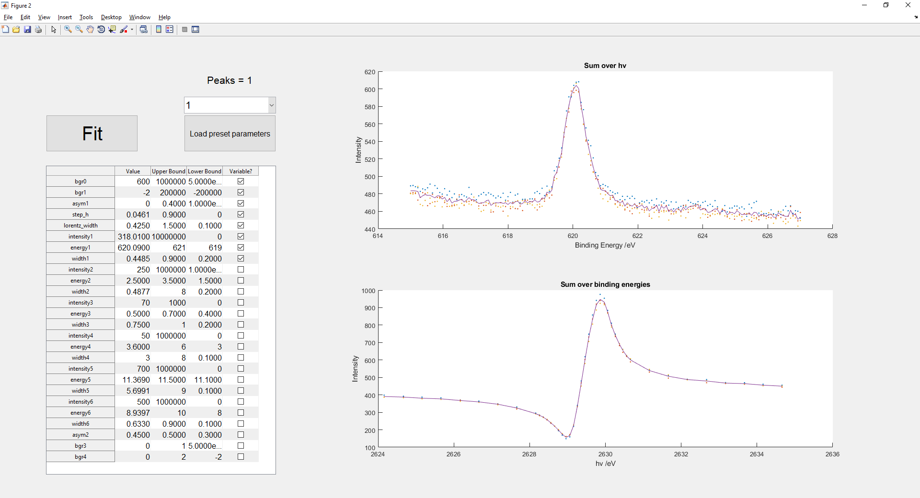

XPS fitting parameters

All data summed over X-ray photon energy, hv, (top) and summed over orbital binding energy (bottom). Average of all data shown with line.

Peak number

A window opens showing the imported data (right) as well as options including number of peaks to fit to the XPS data (top left) and a table showing the base XPS fitting parameters (described below).

Ensure the peak number and fitting parameters are sensible for the data (primarily the energy values). If not edit these values using the table or load in a different parameter set (load preset parameter button).

Important notes:

When editing table values, number in Value column must be between upper and lower bounds or you will get an error. Upper bound must also be greater than lower bound, and vice versa.

When fitting a dataset for the first time, ensure all Variable? boxes are checked up to the number of peaks you are using and none below that (i.e. for 2 peaks, all boxes ticked up to width2 and no others).

When all parameters are set to sensible values, press Fit button to begin initial XPS fitting.

### Table headings:

Value Starting value for least squares fitting.

Upper Bound Upper limit for least square fitting. Value MUST be less than this.

Lower Bound Lower limit for least square fitting. Value MUST be greater than this.

Variable? Toggles whether a fitting parameter is allowed to vary for each photon energy. If on, parameter can vary between upper and lower bounds, with initial an initial value of Value. If off, parameter is held at a constant value (Value column) for all photon energies.

### Fitting parameters:

bgr0 Offset component in fitted background.

bgr1 Linear component of fitted background.

asym1 Asymmetry component of Doniach Sunjic fitting.

step_h Step height of fitted step function.

lorentz_width Lorentz width component of Doniach Sunjic fitting.

intensityN Intensity value (y axis) for Nth peak.

energyN Centre (x axis) of Nth peak.

NOTE: For peaks N>1, energy is measured relative to the position of peak 1!

widthN Width of fitted Gaussian (standard deviation) for Nth peak.

asym2 Currently unused.

brg3 Currently unused.

bgr4 Currently unused.

## XPS fitting

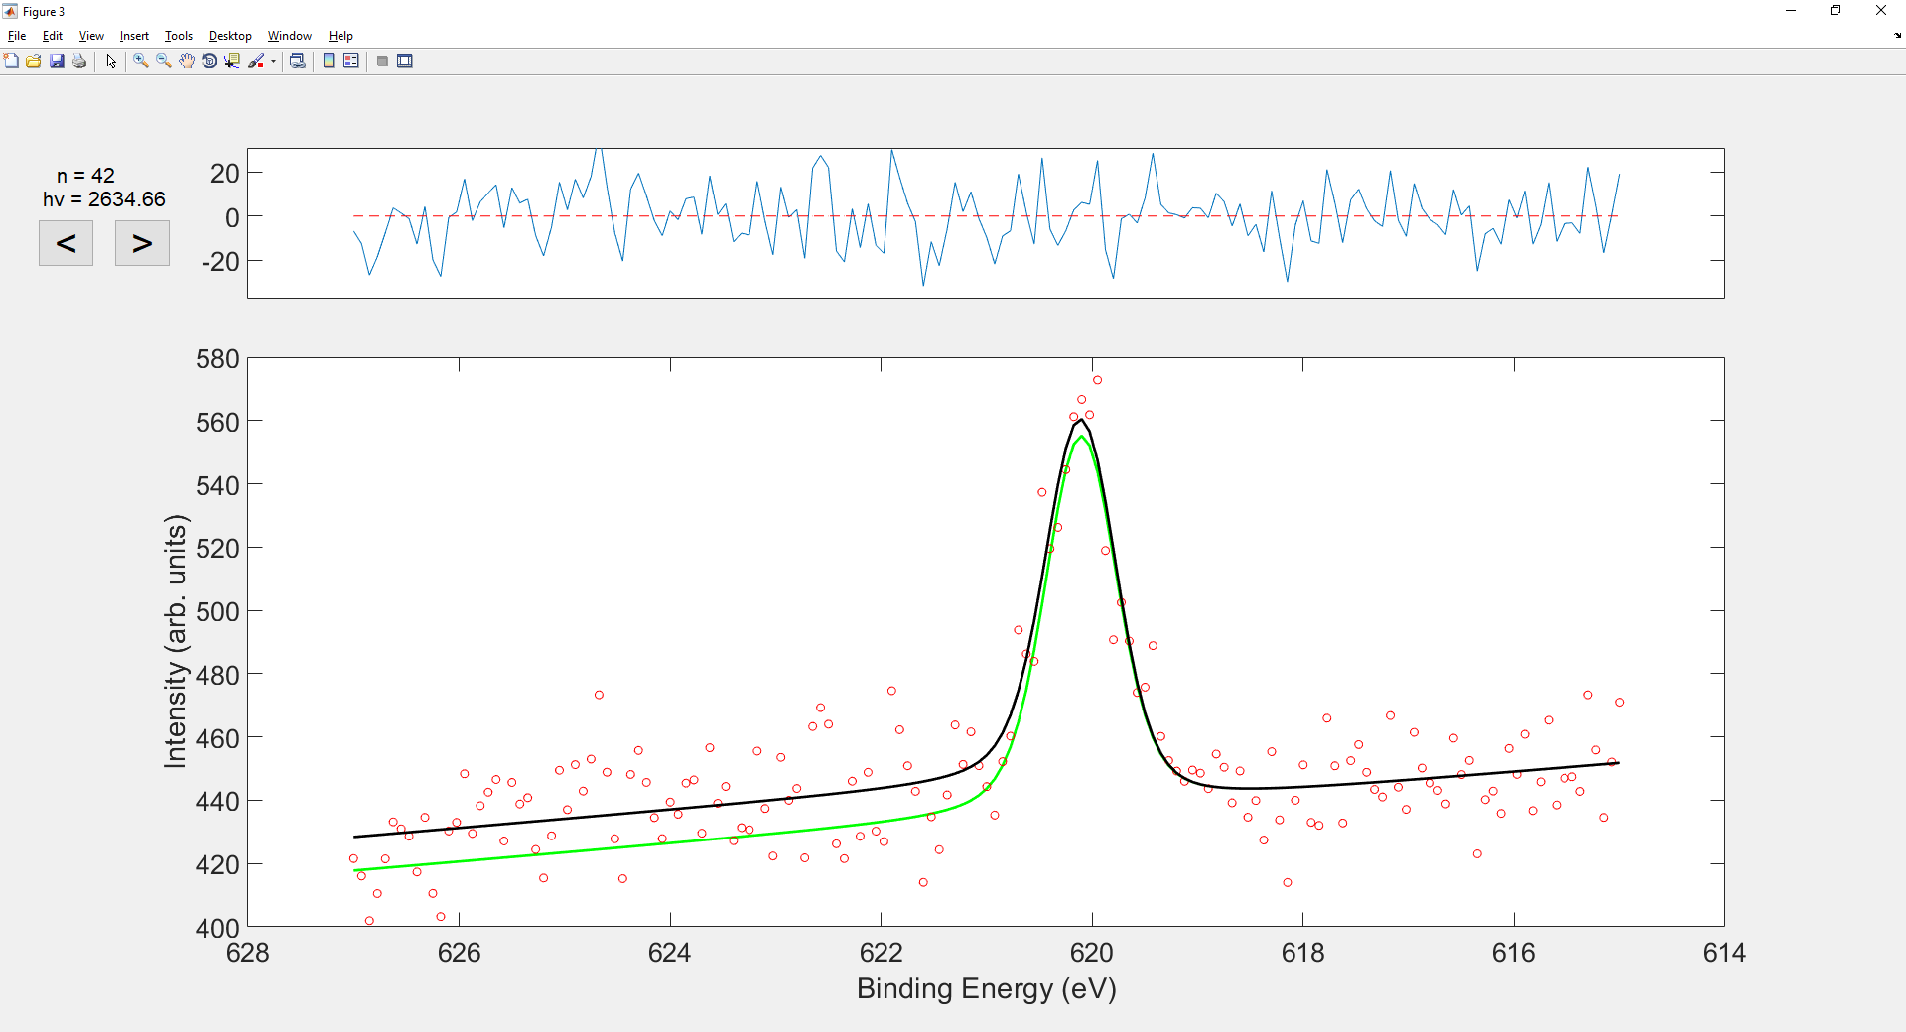

Energy number and photon energy of displayed data. Arrow buttons cycle through each energy (appears after fitting is finished)

Intensity variation with binding energy data for specific photon energy (hv)

Residuals of fitted curve (black) raw data (red)

After pressing Fit button, a new window will open (see above figure). This will cycle through each photon energy (hv), applying peak fitting based on input parameters. While this is happening, check to make sure the applied fit is sensible at each energy.

Once all fits have been applied and displayed, arrow buttons (< and >) will appear and allow you to cycle through the data. This allows you to go back and ensure fits for each photon energy are sensible.

Legend: Red circles Raw intensity data

Black line fitted curve using all parameters

Coloured line Applied fit for Nth peak. Colours cycle: g b m c r k.

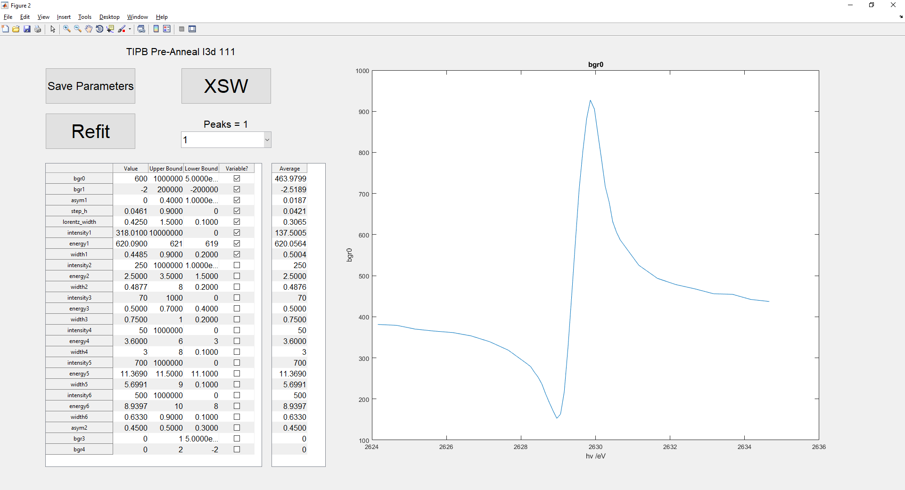

XPS fitting parameters

Average fitting parameter value over all photon energies

Rerun XPS fitting

Save current fitting parameters

Proceed to XSW fitting with current fitting parameters

Variation of selected fitting parameter with photon energy (hv)

After the initial fits have been show, another figure appears. This contains the current fitting parameters and a number of other displays to assist in accurately fitting the data.

From here, edit fitting parameters and rerun the XPS fitting until a representative fit to the data is achieved (**see Tips for fitting data**). This should be such that:

All parameters (except bgr0, bgr1 and intensityN) have been found to not vary significantly with photon energy, then have been set to not vary (variable? Unchecked).

The fit looks representative of all the data, residuals of fitting at each photon energy are as low as possible and there is no pattern in them.

Once a good fit is achieved for all photon energies, proceed to XSW fitting by pressing XSW button. (It is recommended to save your fitting parameters before this).

### Buttons (top left):

Save Parameters Save all fitting parameters to c_data.txt in folder data files were opened from. Overwrites previous saved parameters for this dataset.

Refit Reruns XPS fitting for current fitting parameters, then returns to this figure.

XSW Uses most recent XPS fitting and advances to XSW fitting section. Does not use any parameter changes since last running XPS fitting.

Peaks Options for changing number of peaks fit to XPS data sets.

### Parameter tables (bottom left):

XPS fitting parameters:

XPS fitting parameter controls as above.

Selecting a row in the table will display the variation of that parameter (graph on right) for each photon energy, from the most recent XPS fit.

Average

Displays the average value of each parameter from the most recent XPS fit.

Selecting a row in the table will set the number in the equivalent value column to the displayed average.

### Parameter graph view (right):

Shows the variation of the selected fitting parameter (displayed in the title) with photon energy, for the most recent XPS fit.

### Tips for fitting data

The final aim for fitting is to have a representative fit, with low residuals and all fitting parameters (except bgr0, bgr1 and intensityN) to not vary with photon energy and to be fixed.

How to achieve this can vary depending on data, but the following is good advice on roughly how to start.

1. Select how many peaks to use.

This could be obvious or may be more difficult to decide. You should be able to assign each peak to atoms in a particular environment however. You may need to test fitting you data to different numbers of peaks and see which is best.

1. Go through each parameter one at a time, ensuring it doesn’t vary with photon energy.
   1. Start with one parameter, check to ensure it varies by only small amounts over photon energy.
   2. Set value of parameter to the average value (or other appropriate/representative numer).
   3. Fix the value by unchecking variable?.
   4. Run refit and observe any changes, making sure all fits are still sensible at each photon energy

Repeat process this for each parameter, until all except bgr0, bgr1 and intensityN are fixed.

The best parameter to start with is generally energy1 as this will fix in place each relative to each other. Then change widths and energy, then the remaining parameters.

1. Adjust upper and lower bound options.

This is not always necessary but can help control what parameters try to do and stop the fitting algorithm from getting stuck in a local minima. Narrowing bounds can also limit particular parameters that are varying too much, affecting the overall fitting, and allow you to find the best values for other parameters in the meantime.

Try not to change the bounds too far such that the parameters are constantly at one of the limits. This is a sign that the bounds are over the wrong range or that the fitting is poor.

1. Widths of peaks corresponding to atoms in similar chemical environments should be approximately the same.

Control this by adjusting the upper and lower bound options.

1. Once finished, check all the parameters again.

When all required parameters are fixed, go back through each one in turn, allow it to vary and rerun the fitting. Check to make each is still roughly constant with photon energy and the value used is representative (roughly the average). This ensures that all parameter values work well with the fit and that nothing has changed since fixing them.

It can be worth repeating this several times, especially if there are large changes to the average. If there is a large change between values each time you refit, or some parameters are no longer roughly constant with photon energy, the fit may not be good enough. Try repeating the above steps or changing the number of peaks you are fitting.

## XSW fitting

After a good XPS fit has been achieved and you press the XSW button, a new figure will open. This shows a peak select drop down menu (to select which peak data to perform XSW fitting on), a button (Fit) to run the XSW fit and a check box on whether to auto save the XSW fitting figure after running.

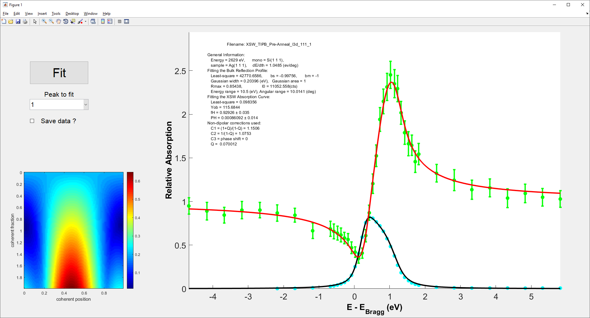

Visual representation of best coherent fraction and position values. Red – bad fit, Blue - good fit.

XSW curves fitted to intensity data for selected peak (red and green) and reflectivity data (blue and black).

Run XSW fit for selected peak

Select peak

Auto save data toggle

Details of data

🡨 Cf and Cp

Pressing the Fit button will run the XSW fitting and produce a figure similar to the one above (note: this can take ~1 min to run).

This produces an XSW fit for the selected peaks, and outputs coherent fraction and position values. This should be repeated for all XPS peaks, noting coherent fraction and position values for each.

### Figure description

Heat map (bottom left):

Gives a visual representation of how good the fit is for all coherent fraction and position values. Red is poor fitting (high error) blue is good fitting (low error). This can be used to check that the obtained fit is not a local minima.

Graphs (right):

Show the peak intensity data (green) and the fitted XSW curve (red). Errorbars are based on XPS data fitting. The reflectivity curve (black and blue) is shown below and should be checked to make sure it is a sensible shape. The top right of the axes also show important details in the data, including coherent fraction (Cf) and position (Cp) values.

Save data? Checkbox:

When checked, saves the XSW figure to the current directory, where the original data was accessed. Data is saved with a name relating to folders the data is stored in, with a suffix “_[peak number]”.

Peak select list:

Select which of the XPS peaks to apply XSW fitting to. Additional option is to calculate the XSW fit for a sum of several peaks. This is by default set to use the sum of all peaks, but can be changed to exclude certain peaks (XSW_analysis.m line, 515). Data from this fitting is saved with the suffix “_a”.

### Common code issues

1. Bragg energy or reflecting plane is not set correctly.

Check in XSW_analysis.m to make sure that the correct value is used. (Look for “%%%%%%%%%% Editable %%%%%%%%%%” marker, around line 475).

1. The wrong surface is selected.

This can be changed in XSW_fitter.m, line 33. Change both the surface name and lattice size.

# Additional Codes

## Coherent_fp_display

Displays coherent fraction and position values in argand diagrams (polar co-orddinates) with errorbars. User inputs calculated values into f_val, p_val, f_err, p_err variables.

## i09_export_XPS

Code for reading and displaying XPS data. Can open more than one file, code then displays all data points and an average.

## Individual_XSW_codes

This is a set of semi-independent codes for analysis of XSW data. For the most part this code is not necessary for analysing data, but does contain some useful features.

Current version requires XSW_analysis folder to be in the directory (so it can access all relevant codes).

Code sections are separated into different cells, run each one individually, you won’t need to use all of them.

1. Load in data.

Used to read XSW data (as with the first section of XSW_analysis.m). Displays data as averages over photon energy and binding energy. Always run this code before the others.

1. XPS fitting.

Fit peaks to XSW data (as with the second section of XSW_analysis.m). Requires c_data.txt file, exported from XSW_analysis.m. Run this code before any XSW analysis section.

1. Manual XPS fitting. (not recommended)

Uses XPS_base.m to manually fit peaks to XSW data (as with the second section of XSW_analysis.m). In general it is better to use XSW_analysis.m for this instead.

1. Display fitting parameter variation. (not recommended)

For use with previous (3) section. Displays output fitting parameters (c_out) variation with photon energy.

1. XSW fitting.

Runs XSW fitting for current fitting parameters (as with the third section of XSW_analysis.m). Run XPS fitting (2 or 3) first.

1. Manual XSW fitting.

Use sliders to manually see how shape of XSW curve varies with coherent fraction (f) and position (p) values. IMPORTANT NOTE: This takes a long time to start, BE PATIENT it is running. Make sure you have the correct Bragg energy, plane and surface (XSW_bodge.m) selected.

1. Cycle through all possible XSW curve shapes.

Displays all possible XSW curve shapes. Make sure you have the correct Bragg energy, plane and surface (XSW_bodge.m) selected.

1. Integrate peak areas.

Calculates the areas under each peak for XSW fitting, and how this varies with photon energy. This is useful for checking if peak assignment is sensible (peak area ratios should be approximately the same as the ratios of assigned chemical environments).

## fit_bodger

Code designed to assist with fitting curves to XSW data, allowing the user to very quickly find the best position for multiple peak datasets.

Code initially asks user to load XSW dataset. Then displays average intensity versus binding energy, averaged over all photon energies.

First, select the number of peaks you wish to fit. This can be changed at any time.

Use sliders to adjust the width and centre position of peaks. The code will then attempt to optimize the fit with the new parameters.

Use sliders to attempt to get an approximate best fitting. (it will be very difficult to get an exact fit using this code).

Use the save button to save fitting parameters to txt file. This can then be imported to XSW_analysis.m as a starting point for fitting.

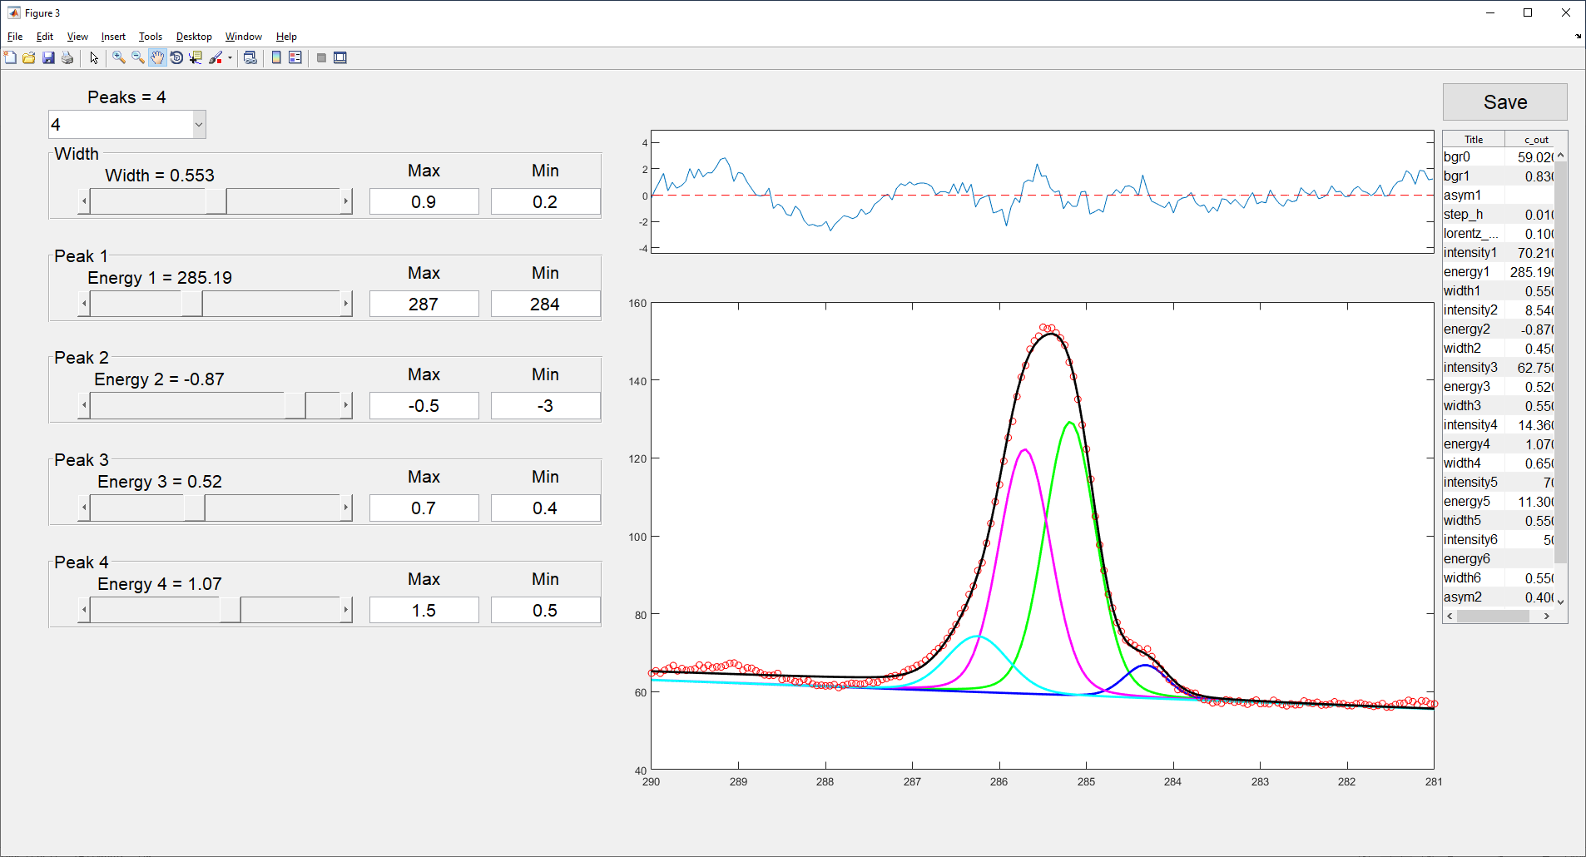

Full list of fitting parameter values

Save fitting parameters to .txt file

Sliders to adjust peak positions

Adjust width of all peaks

Select number of peaks

Residuals of fitting

Average XSW data with fitting

Features:

Peak select Drop down list to number of peaks to fit.

Width Slider Slider to adjust of ALL peaks between Max and Min values.

Peak Sliders Adjust energy (centre) of each peak individually.

Save button Saves fitting parameters to c_data_bodge.txt to current directory.